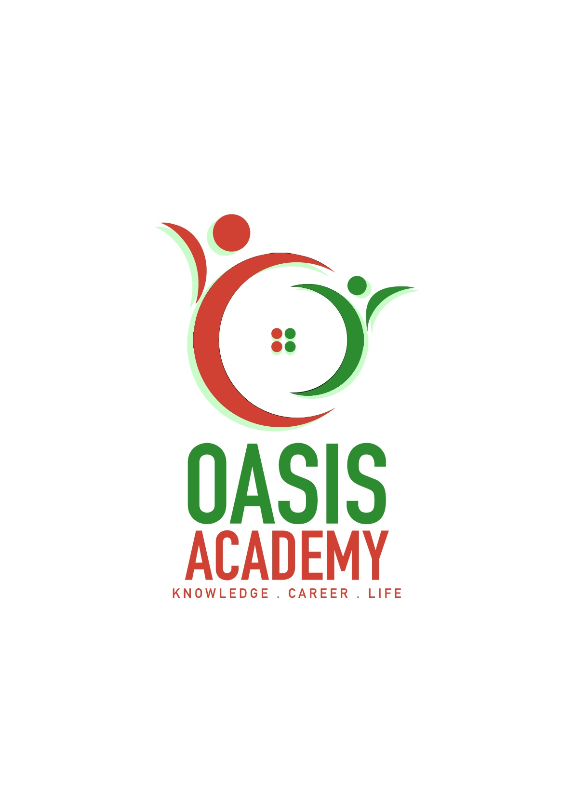

Name: Tan Khoon Eam

Login ID: tankhoon@oasis-portal.com

Course title: Essentials of Human Resource

Subject Code: BHM01

Submitted date: 05/06/2017

**Table of Contents**

|  |  |  |
| --- | --- | --- |
| **No** | **Details** | **Page** |
| 1 | Executive Summary | 2 |
| 2 | Introduction | 3 |
| 3 | Assignment Question |  |
|  | Part 1 | 4 - 5 |
|  | Part 2 | 6 - 7 |
|  | Part 3 | 8 - 9 |
|  | Part 4 | 10 -11 |
| 4 | Conclusion | 12 |
| 5 | References | 13 |
| 6 | Appendix | 14 |

**Executive Summary**

In this module, I learn about the important human resources. Firstly, I learn about the major activities of human resources management regarding the function a company by recruitment, management and providing direction for the people who work within organization, then ways for human resources planning by putting the right person in a position in a position so benefit to company. Furthermore, I will be able to understand about the function and the policies of human resources by selecting a manager level base on their experience, education background and any other qualification skills. Other than this, function of human resource management also included making decision by giving benefit for staff that well perform such as bonuses, allowance, medical facility etc. Lastly, I able to define about the major step in human resources activities and the linking organizational strategy to the employment planning on how to achieve the company mission, objective and goal to ensure that company sustainable and grow.

**Introduction**

Human Resource Management (HRM) is group of people in company mainly to recruitment, management and providing direction for staff that work within the company. HRM also provide knowledge, necessary tools, training, administrative services, coaching and talent management oversight so that company can be successful operation. HR department also responsible to inspire and generates the culture of the company. Other than this, HRM manager play a very important role which is responsibility for the recruitment process and retention of superior employees make sure company is operating efficiently. In order ensure company, keep progressing HR should have a proper plan of the organization, that determine a person and place him/her in right position as an assesses in company. Over the years, growing complexity of business environment and size of organization created more pressure and importance for HR to better execute their role in bringing jobs and talent together in order for an organization to work and progress properly, it’s no longer a monotony role will limited job scopes as it used to be in the pass, more and more distinct division within the HRD and different sub course has been added into the HR courses under studied, including different content serving specific industry like Multi-National-Corporation (MNC), Hospitality, Non-Government Organizations (NGOs), retail and etc. all the above illustrations pointed to importance of elaborated and extensive understanding required in enhancing understanding of this central role in an organization, specifically, this assignment will explore more in relation to hospitality, as tourism gaining more and more attention worldwide as a result of globalization, we shall examine how it at the same time, molded the HR development, its trends and challenges.

**Assignment Questions**

**Question 1**

Define the Major Activities and Human Resources Operation in Hospitality Management (20 Marks)

Hospitality Management cover travel and tourism, hotel, restaurant, recreation facilities industries etc. Human Resources Operation in Hospitality Management mainly refer to an industry that caters to people, and successful hospitality refer to provide a priority and expertly services for their guests. A role of the HR department in Hospitality Management is to recruit good employees and train them to become great employees who enjoy serving others, achieving high level of satisfaction from the customer. In order to hire this kind of person, HR in the company must play a very important role to recruit a person that highly equip interpersonal, out-going, good with people, and hardworking that don’t mind spending a lot of time with their careers during weekends and public holidays.

**Recruiting** - For an example in a hotel that need different kind of man power to operate, to ensure that a company operating efficiently in the first point HR need to planning recruitment of new employee for the position that lack off staff example general manager, assistance manager, housekeeper, food service crew etc.

**Selecting** - Once the company finish up the process of recruiting the HR will start to select the application that they received. HR will review the information resume, application form provided by all job applicants to determine which applicants meet the minimum qualifications after that, those job applicants who meet or exceed the minimum job qualifications are then assessed to decide which ones will be short-listed for the job interview. **(Community Foundations of Canada)**

**Training** - Once the short-listed candidates selected for the job position, HR will then provide a training for those new appointed employees. Throughout this training can assists a person for enhancing his efficiency and effectiveness to particulate work area by getting more knowledge, establish specific skills, abilities etc. To ensure that effectiveness and understanding of the training programs that conducted to participate have been well received HR will come out with a tests and presentations. After throughout training process the employees now can go to the grand floor to performing their self what their had learn.

**Motivation** - In the meantime, if any employees have taken a backseat or less performance company will call up certain employee for consultation section by provide some extra motivation talk, so that the individual would complete the task according to the requirements and accomplish it.

**Evaluation & Compensation –** After a certain working period of an employee in a company, HRM will make an evaluation report base on that employee in every yearly or half yearly basic to review the accomplishment of goals of the employee. Then will base on the performance, rewards the employee in exchange for the services that they provided. The rewards may be increment, allowance, compensation benefits such as dental, free meals etc.

The HR in hospitality management for hotel basically cover front officer that play a very important role as represent company to meet client or customer in the first place that must create a very first impression for the visitor, in the way of very professional, outgoing personality and project genuine warmth. The main duty for housekeeper that also play a very important role of maintaining the high quality of cleanliness and hygiene environment for visitor feel comfortable. To keep a high-quality housekeeping operation, HRD will have group of people performing these duties such as housekeeping manager, housekeeping supervisor and housekeeper. There are also group of people that running food and beverage in the hotel which catering foods and serve hotel guest, they are service crews and chefs that prepare, cook tasty foods. In term to have someone who running all this operation, that is the reasons why we need human resources and human resources management.

**Question 2**

Describe in brief on Human Resources Planning and Planning Trend in Hospitality.

Explain about what is your understanding on Action Plan Human Resources Planning in Hotel Industry. (20 Marks)

Human resources department is the main and important department in a hospitality industry without HR there are no way to operate this industry. Human Resources Planning (HRP) is the process of analyzing and identifying the availability of HR, to achieve the objectives of company. In the other way, HRP is a process that to find, to hire and to keep good employees for achieve company goals. To ensure that company achieve goals, HRD will base on few criterial to make planning. HRP will make sure the right number of the people that short off from the company or the number of department short off from here HRD will make a decision on hiring new employees or switching the staff within the company whichever way that may benefit for company. Besides that, right kind of people that available at the right time, also one of the HRP to ensure that the slot of position is suitable for the right person to take over when there is employee resign. For an example, a position of front office supervisor resigns, at the meantime there are two applicants looking for a job, one applicant previously has 3years experience in hotel front office line, the other one has 3years experience in F&B industry. In this way base on HRP they will select the one that have experience in the front office line to do the right job. The purpose of HRP basically is to plan and decide that what kind of positions to fill with what kinds of people and how to fill them in an organization. The main purpose is to help a company for place the talented people in the right way to benefit company, with more productive and save the cost. These are the few things that HRP will consider it before select an applicant or promote an employee. Forecast into a personal requirement which base on work experience, personal skill, interpersonal, education background etc. Some other causes that need to cope with changes of economic and many others affects some time company has to do some retrenchment and adjustment. Focus on existing manpower for more productively also a part of HRP that generate more production with lesser cost. Promote employees with a systematic way. The important part of HRP to meet future challenges by planning of cut costs and to achieve greater effectiveness, prepare people for future to achieve company goals.

From year to year there are many changes in the planning trend of hospitality. The trend of recruitment now a day will be outsourcing other agency to help or to look for applicant, HRD just to need provide information for outsourcing agency about the need of the organization, from here outsourcing agency will help to do the first round of screening then will provide the name list of the applicants then HRD will only have to do a final selection. In this way will save lot of time consume but have to pay for the service charge. Through internship/graduate intake programme candidate has advantage and disadvantage for new fresh graduate mostly they are lacking working experience. Besides that, the period that they will stay on with company only few months, but the advantage is by this way can help company reduce the cost of just paying them with lower salary. E-Recruitment is the latest trend of recruitment by using this way of recruitment just need to advertise the vacancies through website and all the document from applicants will send and receive by E-mail. By the improvement of technology, it also helps the effective human resource planning by computerized all the HR information into system and from here can get all of the information regarding employees record, succession planning, building skills inventories etc. The trend of responsibility for HRP have become a top management job, that HR plans are usually made by the HR division together with other corporate heads. If there are any deviations from the plans and their causes must be looked into, from time to time in order to assess whether the plans require to revision or modification. **(Slide share)**

The action plan of HRP in hotel industry is HRD will do analyze and forecasting that the people are short off in organization from here then will find and do recruitment either by advertise or through outsourcing agency, from here then they will filter the candidate, which ever that fulfill will need to come for interview. On the other ways, in HRP they may also look on the job function to determine the demand for an example for peak seasons of production seasons this can be handle by temporary workers or assign worker to overtime so that HRD do not need to hire fulltime workers. Basically, action plan of HRP is to ensure the company sustainability in the meantime every few months HRD will make an analyze of internal inventory HR capabilities. A part of that HRD will come out with a productivity plan for every employee by giving target for them, those who is not performing HRD will then give warning letter to ensure that company to grow. When come to the worst part of company that not making profit HRD will come out with a redeployment plan such as retrenchment, this will be also a part of action plan.

**Question 3**

Brief about Human Resources Functions and Human Resources Policies.

Describe the Function of Management and How the policy applies accordingly in Hospitality Management. (20 Marks)

Human resources management basically function is to increase the performance and production activities, relation between the employee of company, as an organization to create more harmony environment so that all the employee can work progressive. An efficiently function of human resources department can provide a company organization with structure and the ability to meet business needs by managing with a group of most valuable resources which are employee.

There are many function of the HR one of the function is to recruitment, in a company if there are any slot of job position HR will do recruitment to fill those positions. In order fill up those slots HR will advertise job postings in website, newspaper and any ways to get candidate, from here then will screen the applicates, interviews applicants and select the one who fulfill company requirement to fit into the company job slot.

Company workplace safety also one of the function operate by HR, under the law employer should provide a safety workplace for employee such as security, surveillance system etc. so that employee can work under a safety environment, HR is the one to plan and hire people. Even though there are some bigger company they may have safety and risk specialists to work and ensure the security of the company.

HR also function as third-party to solve any conflict that happen within the company either between employer and employee, manager with staff or between staff and staff to ensure that employee relation there are no misunderstanding or conflict between each and other. If there are any conflict HR will follow company policy procedure to consult each of them by different ways such as soft flexible talk, motivating, even relocate employee to other department to fulfils employee satisfaction to create a positive harmony working environment to archive company goals and mission.

Other than this, HR also function to evaluate employee and base on their performance to provide compensation and benefit. Basically, employee that work with a company longer period and higher position will get more compensation and benefit compare with fresh people in a company. In this part HR will function by setting the compensation structures evaluating, survey and make comparison of compensation and benefit scheme that provide can be compete with other company to ensure that those well perform employee can stay on with company. Normally the compensation and benefit will come with the increment of salary, bonuses, incentives, allowance, medical insurance, company car etc.

Training and development is one of the main and important function by HR, training is a basic tool for a new employee to get know how company function, progress and culture, without training very difficult for a new employee to be success in company. Training and development not only for new employees, company also provide leadership training and professional development for some newly hired and promoted supervisors and managers on topics such as performance management and how to handle employee relations matters. This is very important part of company to drive employees to grow with company toward the success.

Every different company will their own company policies. Human resource policies are the rules and guidelines for to place, to hire, train and reward the employees with guide of policies can serve to preempt many misunderstandings between employees and employers about their rights and obligations in the business place. Human resource policies including employee rights and duties. HR policies are tied to employment law. To avoid non-compliance and penalties from the government, employers must adhere to HR policies. Employees must play their part by complying with the human resource policies that relate to them. With these policies will reduce misunderstanding and employees will knows what they must do and what should not do when on and off duties, so that company can progress smoothly and reduce the unnecessary things to be happen such as working hours, annual leave entitlement, benefits, overtime compensation, performance evaluations and salary increases etc. **(Chron)**

These are the few examples of policies that applies in hospitality management, organizational structure is one of the policy that will applies in hotel and F&B line, with this organizational structure there will more systematic for employees to know who they need to report. Besides that, employees will be clearer about what is their division, task and responsibilities through this organizational structure. Each and every company will come out with their own legal issues policy, which is rule and regulation regarding the minimum working hour, work public holiday, entitlement overtime, emergency leave, sick leave, leave entitlement, termination of employment. Different company will come with different scheme of leave entitlement, some company request to work for one whole month only entitle for 1day of annual leave, some company will have 14days of annual leave per year some company may only have 12days of annual leave per year so this will depend on the company policies. Most of the companies will take very serious action on termination of employment policy issues. Regarding this issue normally employer will request HR prepare contract of working period with a minimum one to two years depend on different company of policy, whoever that fail to fulfill company will then take legal action on this. Beside that all of the employees in a company have different policy and supervision guide. For new trainees, their main duties will start from the basic serve customer, housekeeping, maintaining cleaning hygiene and report to supervisor. Supervisor will then ensure the people that supervise by them carry out their duties properly make report to assistance manager or manager. Other than this, there are some other consistency policy such as basic salary that will be pay for an employee every month, compensation and benefit that provide such as medical fees and insurance. Rules and regulation regarding what cannot be done when working time such as playing with handphone, not focus when on duties. Without a proper HR policies, there are very difficult for an employer and a company to control the people to grow and operate with.

**Question 4**

Explain in detail about Organizational Behavior in Hospitality and brief on Groups and Structure in Organization (20 Marks)

Organizational Behavior (OB) is the study of the way employee interact with each other and people interact within group. It started to gain recognition as an academic field of study since it recognized by American Psychological Association in the 1970s. Usually thought in business schools and schools of social work and psychology, it is one of the mandatory credits to be taken in business and management courses, explains its significance and importance of understanding of the subject to the overall well beings of business and organizations. **(Search Investopedia)**

The central idea of the study of the Organizational Behavior is that a scientific approach can be applied to the management of individuals, groups and structure within organizations, for the ultimate purpose of improving organization’s effectiveness and maximize output from individual group members. Hence, different models and philosophies of organizational behavior had been studied targeting to improve job performance, increasing job satisfaction, promotion innovation and encouraging leadership. A holistic Organizational Behavior approach draw findings from the fields of psychology, sociology, anthropology, and political science, and several quantitative, qualitative, and computer models used for analyzing data, generate insights and explore methods for execution.

• Psychology - is the scientific study of the human mind and its functions, especially those affecting behavior in a given context.

• Sociology - is the study of the development, structure, and functioning of human society. Synonymous with Social Science, is the study involving in depth analysis of human social activity with the intention to applying such knowledge to the pursuit of social welfare.

• Anthropology - focuses on human activities, which studies human societies and cultures and their development, which involves the study of human biological and physiological characteristics and their evolution

• Political Science - is the branch of knowledge that deals with the state and systems of government; the scientific analysis of political activity and behavior, it remains a key area of study within Organizational Behavior simply because no organizations exist without some forms of political structure, bureaucracy, or segmentation of control.

In Hospitality, where most of the jobs still performed by humans and not automated machines, individuals’ contributions are expected to be at higher standard in ensuring the organization’s success. When employees with various personalities joint together in performing various jobs, there are certain fundamental consistencies still expected out of each and every one, at the same time, being able identify and value differences among individuals that contributed to the overall diversify or workforce and organization’s success. Increased pressure has been placed on Human Recourse Department (HRD) since employment landscape for hospitality has been changing and continue to be challenging for HRD in combating work force diversity, declining employee loyalty, labour shortage and skill deficiencies. Organizational Behavior in hotels industry, or in other words, hospitality helps to instill new employee attitudes, behaviours and values that can brings out stellar performance and improve competitive edge of the organization.

In general, organizations are affected by several forces that shape the business environment and competition landscape, the forces can be classified into four key areas like people, structure, technology, and environment. The study of Organizational Behavior focuses on finding effective means to influence these variables, with the intention to produce a cohesive force that positively change the organization. To illustrate, when a new employee (people) firstly joining the organization, he/she will first undergo orientation, training will be provided, including duties that will be carried out, a systematic structure will be in place to prepare the new staff, so that he/she able to contribute to the company’s success, performance measurement and rewarding programs are also part of the structure in place to boost overall productivity. In order to maximize the productivity of the staff, machinery, gadgets and software (technology) will be in place to assist the employee to achieve the organizational goals. However, they must always monitor and anticipate changes from external environment that could possible post thread or offer opportunities for the organization. People plays an important role, especially in hospitality, employee are expected to hospitable with great attitude towards the guests and up hold to the correct ethics and value. Few things that HRD should concern in keeping their best employee are organizational commitment, quality of workplace, compensation and motivation, study of Organizational Behavior should be properly viewed as a mean for solving the above concern in the long run.

**Conclusion**

Every organization need Human Resource Department or in certain extend, carry out its function along the course of business, small enterprises and SME might don’t have a well-established HRD but the main functions (hiring, training, evaluating, compensation, etc) are still exist carried out by business owner himself. A larger organization will have a full fledge HRD as a centralized functional unit to cater to diverse needs within the organization. The industry covered in this assignment is tourism and hospitality, specifically, I am taking this opportunity to uncover the various implications of Human Resources functions in tourism and hospitality operations (ETHO).

Throughout the assignment, I came to gain a clearer understanding on the history and development of Human Resources Operations in hospitality management to be specific, Tourism and hospitality in recent days have grown so complex and business landscape have also evolve into the reality that Human Resource Operations will also need to be align with the changes, that brings about to one of the sub topic covered in this assignment, to learn about the Human Resources Functions and Human Resources Policies and its application in Hospitality. Secondly, we layout several Human Resources planning and planning trends in hospitality, in depth, I also suggested action plans in relation to the planning mentioned. Lastly, I also learnt about how Human Resource utilizes Organizational Behavior in improving the overall output and increase efficiency of employee and organization.

**References**

1. **Community Foundations of Canada (online)** - **Getting the Right People**

<http://hrcouncil.ca/hr-toolkit/right-people-selection.cfm>

1. **Slide share - Human Resource Planning In Hotel Industry in Present. HRP's Importance, Limitations, Effectiveness and Latest Trend in Hotel Industry. Published on Sep 21, 2014 (online)** <https://www.slideshare.net/ZeinulHaleem2/human-resource-management-in-hotel-industry>
2. **Chron (online) by Grace Ferguson - Define HR Policy** <http://work.chron.com/define-hr-policy-22825.html>
3. **Search Investopedia (online) - Organizational Behavior – OB** <http://www.investopedia.com/terms/o/organizational-behavior.asp>

**Appendix**

Refer to question 3 organizational structure.

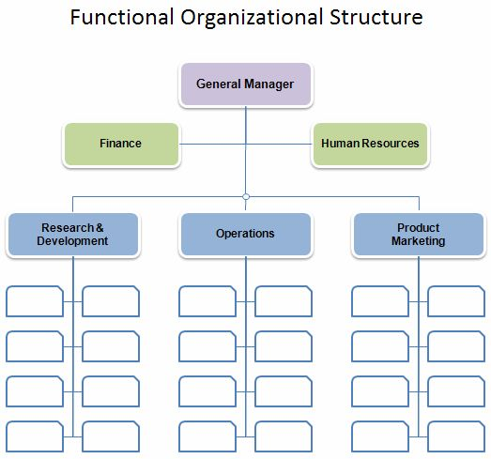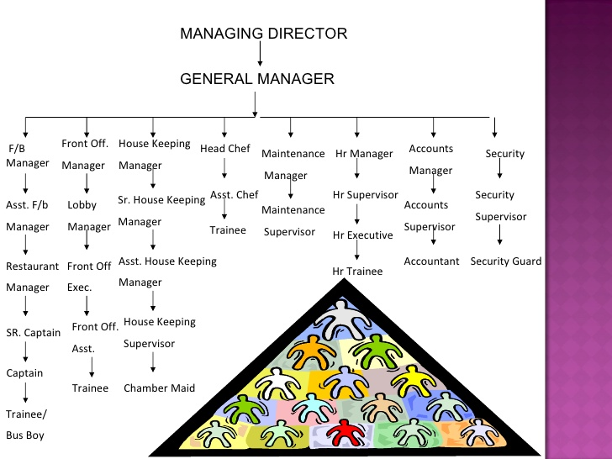

1. <https://www.google.com.sg/imgres?imgurl=https%3A%2F%2Fs-media-cache-ak0.pinimg.com%2F736x%2Fe0%2Feb%2Fb0%2Fe0ebb0a8bdd0b8627a75d131f0e8d0c8.jpg&imgrefurl=https%3A%2F%2Fuk.pinterest.com%2Fexplore%2Forganizational-structure%2F&docid=mPlYpGOCw3lhpM&tbnid=8hPwJgkVD3EFUM%3A&vet=10ahUKEwjoyJ_r4KXUAhWCpo8KHas-CQ0QMwgwKBEwEQ..i&w=523&h=489&bih=638&biw=1366&q=organizational%20structure%20policies%20hotel%20line&ved=0ahUKEwjoyJ_r4KXUAhWCpo8KHas-CQ0QMwgwKBEwEQ&iact=mrc&uact=8>
2. <https://www.slideshare.net/mahekdhoot/hotel-oranizational-structure>

THE END